Erin McKee
It is with great sadness that we say goodbye to Erin and offer condolences to his wife, Heather,and children, Laura and Collen. A service is being held on Saturday, October 28 at St Mark’s Church.

PRSTA Office
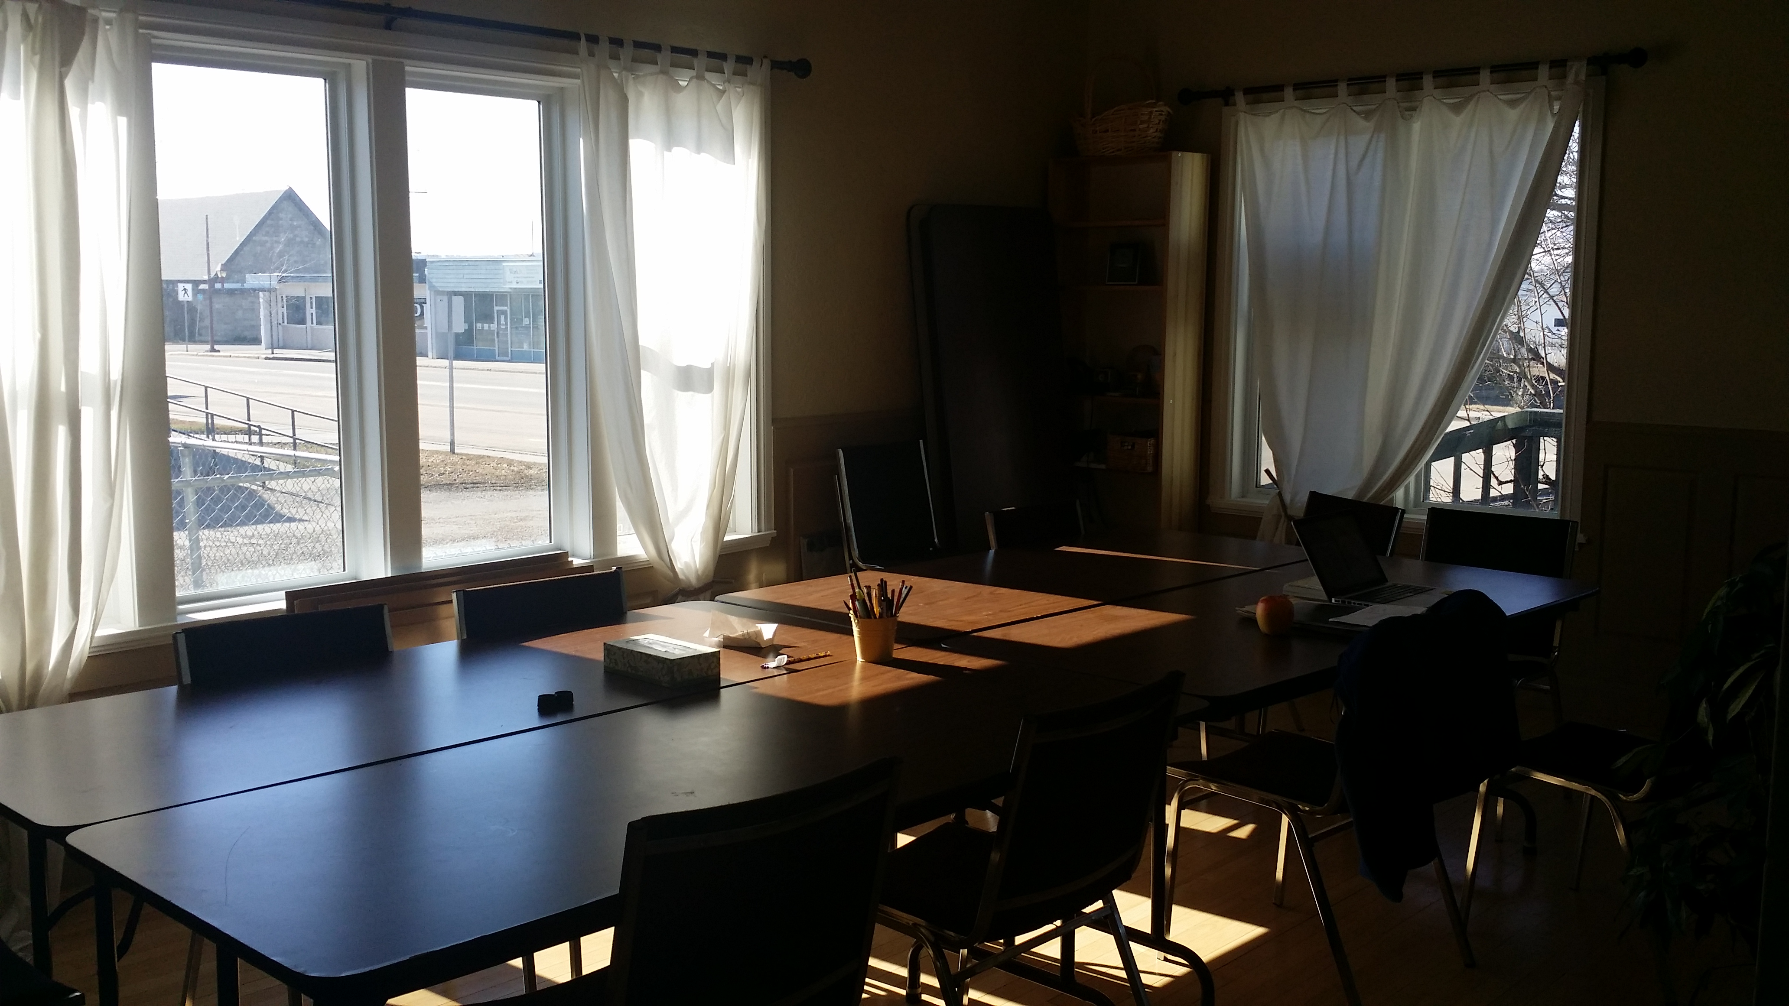
We are excited to be in our new office space! The address is: 1120 103rd Ave. If you haven’t had a chance to check it out, please come by. (Phone first to be sure someone is in.)

To see the minutes and key decisions from the Federation's 2017 Annual General Meeting are now at: www.bctf.ca/publications/BCTFNews.aspx
Feel free to call Elaine if you have any questions, 250 219-1284
The BCTF has a site called TeachBC which has different resources for teachers. Check it out at: http://teachbc.bctf.ca/

Collective Agreement
‘All teachers should have a copy of the collective agreement (contract), either on USB or a paper copy. Please contact Deirdre McDonald by email if you do not have a copy. Thanks

Bill C-27
.

Benefits Improvements
The charts below show the benefit improvements to our plan for this year and next year. If you have any questions, you can call the BCTF or go to website.
ph: 1-800-663-9163 or http://www.bctf.ca
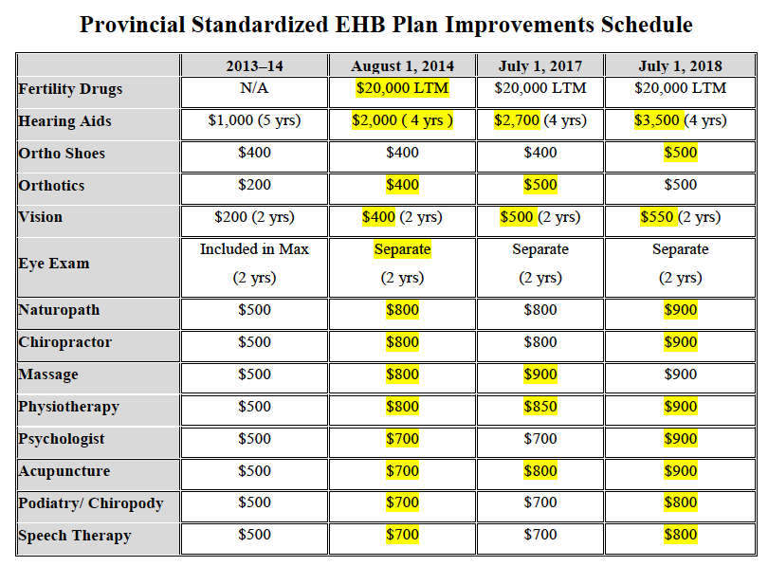

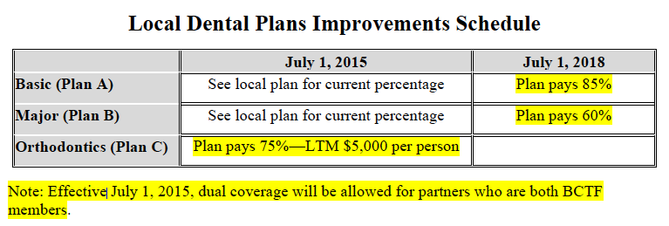

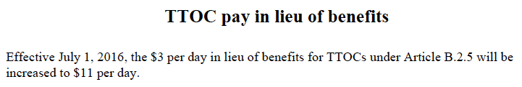

Long Term Leave Changes
Subject: Long Term SIP Withdrawal - Revised advertisement
The Long Term SIP Withdrawal notice which you have grown accustomed to seeing in every issue of the Teacher Magazine has been revised to incorporate the changes to Regulation 21.1 of the Salary Indemnity Plan. At the 2017 AGM, Regulation 21.1, which addresses the duration of LTD benefits, was amended to reflect the recent changes to the Teachers’ Pension Plan. Those changes have resulted in new a criteria being applied to Long Term SIP Withdrawal applications from members.
Going forward, please use the attached notice in your local communications when informing members about their ability to apply for withdrawal from the long term portion of the Salary Indemnity Plan.
Regards,
Christine Choinski for Sarb Lalli
Sarbrinder Lalli, Salary Indemnity Plan Administrator
Tel: 604-871-1935 / Fax: 604-871-2287 / slalli@bctf.ca
Toll Free: 1-800-663-9163, local 1935
Professional Development
We hope that your Professional Development Day went well. These days take time to plan and you attendance is appreciated.
Good job, Meagan Harder our new ProD rep for the PRSTA, and her ProD staff rep support, especially Elaine, who is presently our ProD Treasurer ( but looking for someone to take on the position!)

EFAP & WHIP

A reminder that
the District has the EFAP program available to support employees. Your family is eligible for up to 6 session total with a counselor. Check the Walmsley web site regarding accessing this program. All information is confidential.
https://www.walmsley.ca/

Also, a reminder that the District has the WHIP program on the eservices link. Fill in each day and earn points and then treat yourself to a free service or gift certificate.

